Fahmi Auliya

140810170041

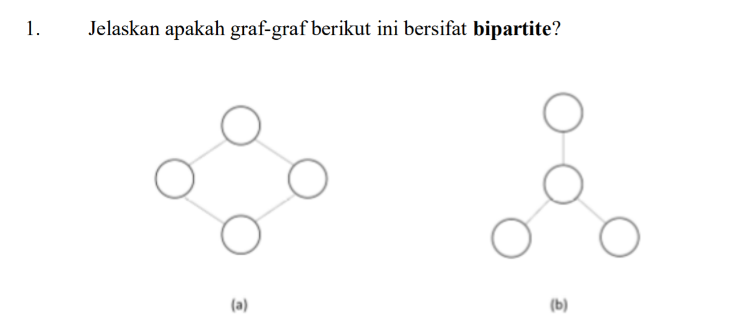

1. Graf ini bipartite

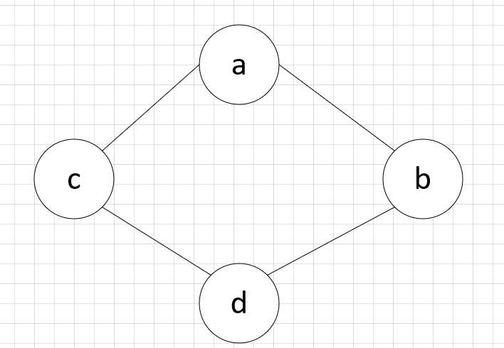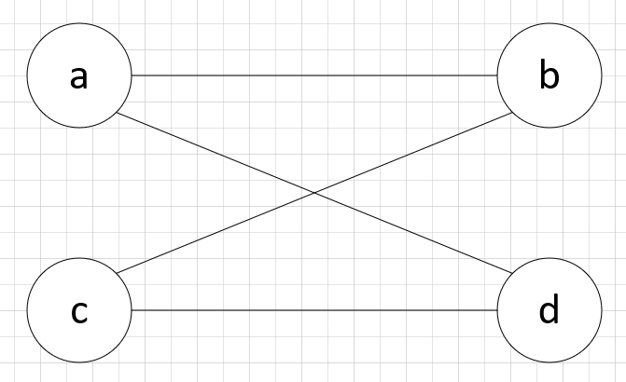

1. Graf ini bipartite

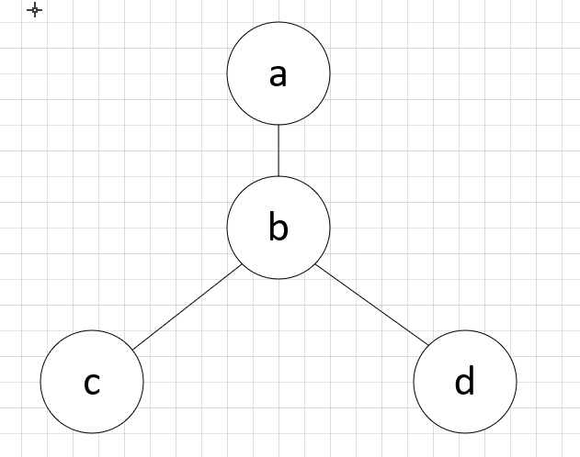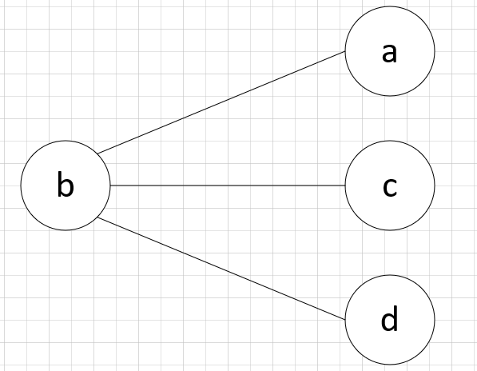

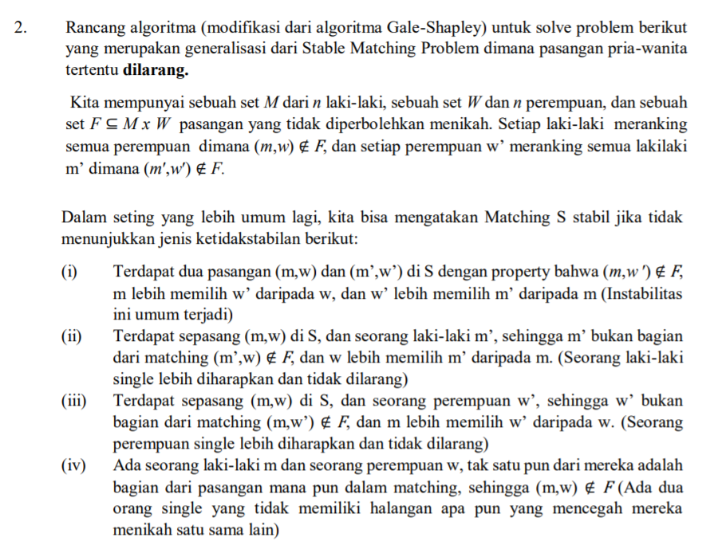

Initially m ϵ M and w ϵ W are free

While there is a men m who free and hasn't proposed to every woman

choose such a man m

Let w be the highest-ranked woman in m's preference list to whom m has not yet proposed

If w is free then

(m,w) engaged

Else w is currently engaged with m'

If w prefers m than m' then

(m,w) engaged

Else w prefers m' than m then

If m' prefers w’ then

w remains free

Else m' choose w then

m remains free

Endif

Endif

Endif

Endwhile

Return the set S of engaged pairs